Creating an AI-Generated Advertisement Video for MuteMix Using AI Tools

Introduction
MuteMix is a futuristic silent portable blender bottle designed for modern lifestyles. It combines portability, whisper-quiet blending, premium aesthetics, and convenience into one compact device. AI-powered creative tools can be used to produce a professional-quality commercial advertisement for MuteMix without requiring expensive cameras, studios, or production teams.

This document explains how to create a premium cinematic advertisement video for MuteMix using AI-based tools such as [ChatGPT](https://chatgpt.com?utm_source=chatgpt.com), [Murf AI](https://murf.ai?utm_source=chatgpt.com), [Google Flow (Veo 3)](https://labs.google/flow?utm_source=chatgpt.com), and [Adobe Express](https://www.adobe.com/express/?utm_source=chatgpt.com). The procedure includes script generation, AI voice creation, scene planning, cinematic video generation, editing, and exporting the final advertisement.

Objective
To design and generate a premium AI-based advertisement video for MuteMix that highlights its silent blending technology, portability, sleek design, and modern lifestyle appeal using cinematic visuals and AI-generated narration.

Tools Requirements
- Hardware
- A computer or laptop with stable internet access
- Updated web browser (Chrome recommended)

Software / Platforms
1. [ChatGPT](https://chatgpt.com?utm_source=chatgpt.com) – for scriptwriting and prompt generation
2. [Murf AI](https://murf.ai?utm_source=chatgpt.com) – for cinematic AI voiceover generation
3. [Google Flow (Veo 3)](https://labs.google/flow?utm_source=chatgpt.com) – for AI-generated cinematic video scenes
4. [Adobe Express](https://www.adobe.com/express/?utm_source=chatgpt.com) – for editing and assembling the final advertisement

Reference Material
- Product images of MuteMix
- Blender visuals and lifestyle footage
- Product script and storyboard

Overview of the AI Workflow
Before beginning the advertisement creation process, it is useful to understand the role of each AI tool:

ChatGPT
Used for generating:
- Advertisement scripts
- Scene descriptions
- Voice prompts
- Cinematic video prompts

Murf AI
Used for:
- Premium AI-generated male narration
- Natural cinematic voice delivery
- Background music synchronization

Google Flow (Veo 3)
Used for:
- AI-generated cinematic product scenes
- Smooth camera movement
- Futuristic visual generation
- High-quality promotional shots

Adobe Express
Used for:
- Video editing
- Scene arrangement
- Text animation
- Transition effects
- Background music mixing
- Exporting the final HD advertisement

Step-by-Step Procedure
Step 1: Identify the Product Concept
Before generating visuals, define the overall advertisement style.
Product
MuteMix – Silent Portable Blender Bottle

Target Audience
- Students
- Fitness enthusiasts
- Travelers
- Office professionals
- Modern tech users

Advertisement Tone
- Premium
- Futuristic
- Minimal
- Cinematic
- Apple-style modern commercial

Key Features to Highlight
- Silent blending
- Portable design
- Lightweight body
- Stainless steel blades
- Premium matte finish
- Easy carrying

Step 2: Generate the Advertisement Script Using ChatGPT
Use ChatGPT to generate a professional cinematic commercial script.
Prompt Used for Script Generation
Product: MuteMix
Generate a premium cinematic male commercial voice for a futuristic tech advertisement.
Voice Style
- Deep male voice
- Calm and confident
- Premium luxury commercial tone
- Smooth modern delivery
- Natural conversational pacing
- Slight cinematic energy
- Clean pronunciation
- Warm low bass tone
- Minimal exaggeration
- Apple-style product advertisement feel
- Professional but friendly
- Modern tech commercial vibe

Voice Emotion
- Premium
- Confident
- Smooth
- Relaxed
- Futuristic
- Sophisticated
- Speaking Style
- Slow to medium pace
- Small pauses between feature lines
- Natural breathing
- Clean sentence transitions
- Smooth premium flow

Background Music Style
- Futuristic electronic beat
- Soft cinematic bass
- Elegant ambient synth
- Premium startup advertisement vibe
- Smooth transitions
- Non-overpowering music

Step 3: Generated Advertisement Script
Opening Scene
A modern portable blender bottle placed on a clean white table with soft cinematic lighting.

Voiceover
“Introducing MuteMix, the portable bottle blender designed for modern life.”

Scene Transition
Fresh fruits drop into the bottle while the blender runs quietly.

“This smoothie is actually really good.”

“And the bottle looks so clean.”

Close-Up Shot
Premium matte finish and sleek bottle design shown in slow motion.

“Clean and premium.”

Lifestyle Scene
A person carries MuteMix in a backpack while traveling outdoors.

“I like how easy it is to carry around.”

“Yeah, portable blending.”

Product Feature Scene
Close-up view of stainless steel blades blending fruits smoothly.

“Powered by precision-engineered stainless steel blades for smooth and effortless blending.”

Final Scene
MuteMix displayed beside fresh juice with glowing futuristic lighting.

“Compact, lightweight, and ready to go anywhere.”

“Meet MuteMix. Powerful blending, whisper-quiet performance, and fresh juice anywhere you go.”

Step 4: Generate AI Voiceover Using Murf AI
1. Open [Murf AI](https://murf.ai?utm_source=chatgpt.com).
2. Create a new voiceover project.
3. Paste the generated commercial script.
4. Select a premium deep male cinematic voice.
5. Adjust settings:
- Slow-medium pace
- Warm bass tone
- Natural breathing
- Smooth pauses
6. Add soft futuristic background music.
7. Export the final narration in MP3 format.

Step 5: Generate Cinematic Video Scenes Using Google Flow (Veo 3)
Access Google Flow
1. Open [Google Flow](https://labs.google/flow?utm_source=chatgpt.com).
2. Sign in using a Google account
3. Create a new project named: “MuteMix Advertisement”

Step 6: Upload Product Reference Images
Inside Google Flow:
1. Open the Ingredients panel.
2. Upload high-quality images of MuteMix
3. Upload reference backgrounds such as:
- Modern kitchen
- Futuristic workspace
- Outdoor travel environment
4. Label the ingredients properly
Example:
- MuteMix_front
- MuteMix_side
- MuteMix_blending

Step 7: Write Detailed Cinematic Prompts
The quality of AI-generated video depends heavily on the prompt quality
Recommended Prompt Structure
- Subject : MuteMix blender bottle
- Action : Blending fruits quietly
- Camera : Slow-motion close-up, cinematic orbit
- Lighting : Soft white rim light, premium reflection
- Environment : Modern minimal workspace
- Style : Hyper-realistic, futuristic, cinematic

Example Video Prompt for MuteMix
A futuristic portable blender bottle called MuteMix sits on a clean white table in a modern cinematic studio. Fresh strawberries and bananas fall into the transparent bottle while the blender runs silently. The camera performs a smooth slow-motion orbit around the matte-black base with glowing white LED power light. Soft rim lighting reflects on the bottle surface. Fresh juice swirls smoothly inside the bottle. Style: hyper-realistic, cinematic, premium Apple-style commercial, 4K, 24 fps, shallow depth of field, elegant ambient lighting. Audio: soft futuristic synth and cinematic bass. No subtitles.

Step 8: Generate Video Scenes
1. Paste the cinematic prompt into Google Flow
2. Attach the uploaded MuteMix ingredient images.
3. Set clip duration between 5–8 seconds.
4. Click Generate.
5. Review the generated outputs
6. Select the best cinematic scene.
Repeat this process for multiple scenes:
- Product reveal
- Fruit blending
- Lifestyle carrying scene
- Close-up blade shot
- Final hero shot

Step 9: Edit and Assemble the Advertisement
Use [Adobe Express](https://www.adobe.com/express/?utm_source=chatgpt.com) for post-production.

Editing Process
- Import
- AI-generated video clips
- Murf AI voiceover
- Background music

Add
- Smooth transitions
- Cinematic text animation
- Product feature highlights
- Logo and tagline
- Synchronize
Match scene transitions with narration timing.

Recommended Effects
- Slow zoom
- Fade transition
- Motion blur
- Soft glow lighting

Step 10: Export Final Advertisement
1. Preview the final video.
2. Export in:
1080p HD or
4K MP4 format
3. Save the completed advertisement video.

Sample Storyboard for MuteMix Advertisement
Shot 1 (0:00–0:04)
MuteMix appears on a clean white table under soft cinematic lighting.

Shot 2 (0:04–0:08)
Fresh fruits drop into the bottle while silent blending begins.

Shot 3 (0:08–0:12)
Close-up slow-motion shot of stainless steel blades blending smoothly.

Shot 4 (0:12–0:17)
Person carries MuteMix inside a backpack while walking outdoors.

Shot 5 (0:17–0:22)
Final hero shot with fresh juice beside the blender and glowing premium lighting.

Tips and Best Practices
- Write prompts like directing a real cinematographer.
- Use clear cinematic terms such as:
- Close-up
- Dolly shot
- Orbit camera
- Rim lighting
- Slow motion
- Maintain consistent lighting across all scenes
- Generate multiple scene variations and select the best clips.
- Add text overlays during editing instead of generating text inside AI videos.
- Keep the advertisement short and visually engaging.

Limitations
- AI-generated text inside videos may appear distorted.
- Multiple generations may be required for accurate visuals.
- Consistent product appearance across scenes can sometimes vary.
- High-quality AI generation requires stable internet and subscription access.

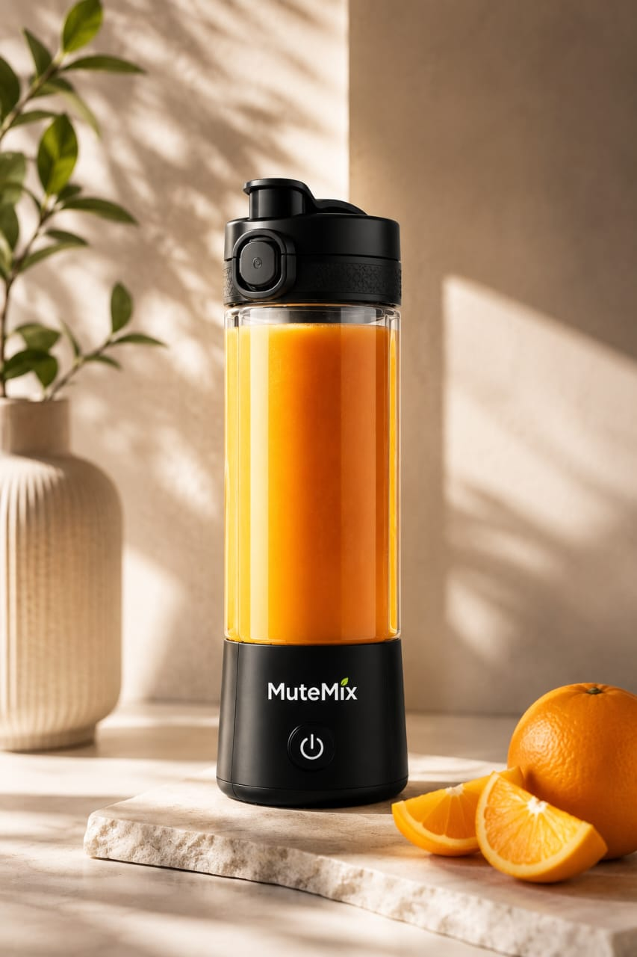
Reference image used for video generation

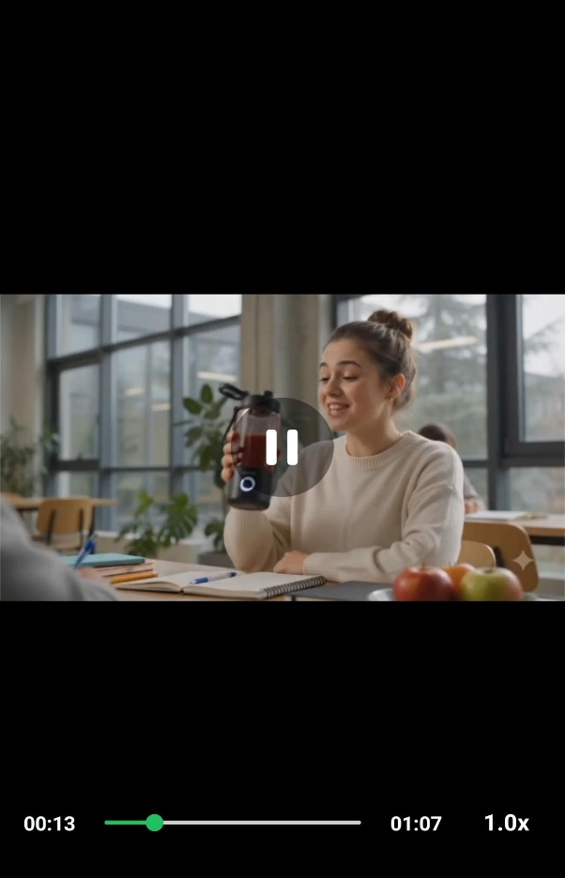
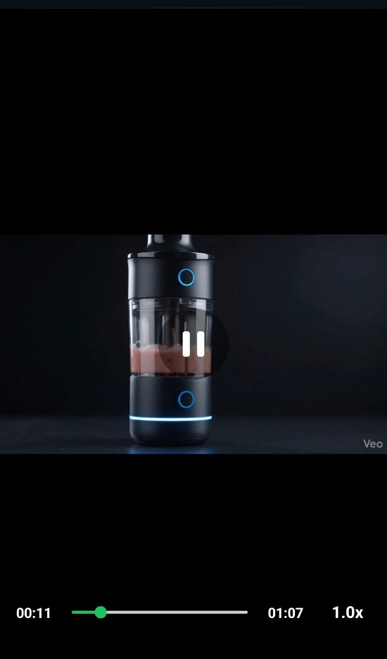
A Screenshot clip of generated video
Result
A premium AI-generated advertisement video for MuteMix was successfully created using ChatGPT, Murf AI, Google Flow (Veo 3), and Adobe Express. The final commercial featured cinematic visuals, smooth transitions, futuristic background music, and professional AI narration. The advertisement effectively showcased the silent operation, portability, and premium modern design of MuteMix.

Conclusion
AI-powered creative tools make it possible to produce professional-quality product advertisements without traditional filmmaking equipment. By combining script generation, cinematic voiceovers, AI video generation, and modern editing techniques, MuteMix can be presented as a futuristic lifestyle product with strong visual appeal. This workflow can also be adapted for other product promotions, startup advertisements, and modern commercial campaigns.

